Buffalo Mountain Bluegrass Band

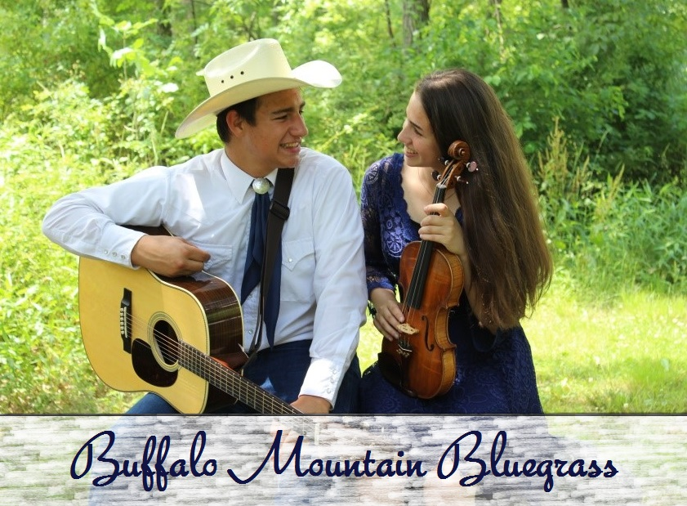

The Buffalo Mountain Bluegrass Band consists of the home schooled sister and brother duo, Autumn and Canyon Moore. They have been performing together since 2008, and they play a variety of music styles including, but not limited to, Bluegrass, Gospel, Civil War, Patriotic, Country, Irish, Canadian, and Scottish. The duo performs regularly at a variety of venues, and they are excited to share their love of music with others. To learn more about them, visit their website: www.buffalomountainbluegrass.com.

Buffalo Mountain Bluegrass Band
Autumn & Canyon Moore
(717) 275-3497
www.buffalomountainbluegrass.com

